Tab 1

Lab 2: Enterprise Migration & Zero-Trust Network Isolation: Synapse-to-Fabric Security Governance & Hybrid Gateways
Property | Value
Module | Module 1: Foundation: SaaS Architecture & Synapse Migration
Lab Number | Lab 2
Lab Name | Enterprise Migration & Zero-Trust Network Isolation: Synapse-to-Fabric Security Governance & Hybrid Gateways
Duration | 4 Hours
Difficulty | Intermediate / Advanced
Operating System | Browser-based (Windows/Linux/macOS) with Azure Cloud Shell
Primary Technology | Microsoft Fabric Portal, Azure Portal
Supporting Technologies | Azure VNet / Private DNS Zones, Integration Runtimes (SHIR/Azure IR), Microsoft Purview, Azure Monitor / Log Analytics
Learning Objective | Configure a zero-trust network-isolated Fabric environment by deploying workspace Managed VNets, OneLake Private Endpoints, Self-Hosted Integration Runtimes (SHIR), and enterprise security auditing via Purview and Azure Monitor.

Step-by-Step Execution Guide

Phase 0: Azure Network & Security Infrastructure Provisioning

Step 1: Deploy Virtual Network & Subnet via Azure Portal
- Go to Azure Portal and search for Virtual networks, then click + Create.
- Basics Tab:
  - Subscription: Select your active lab subscription.
  - Resource Group: Choose LabsKraft-AI.
  - Name: vnet-fabric-eastus-01
  - Region: Australia East
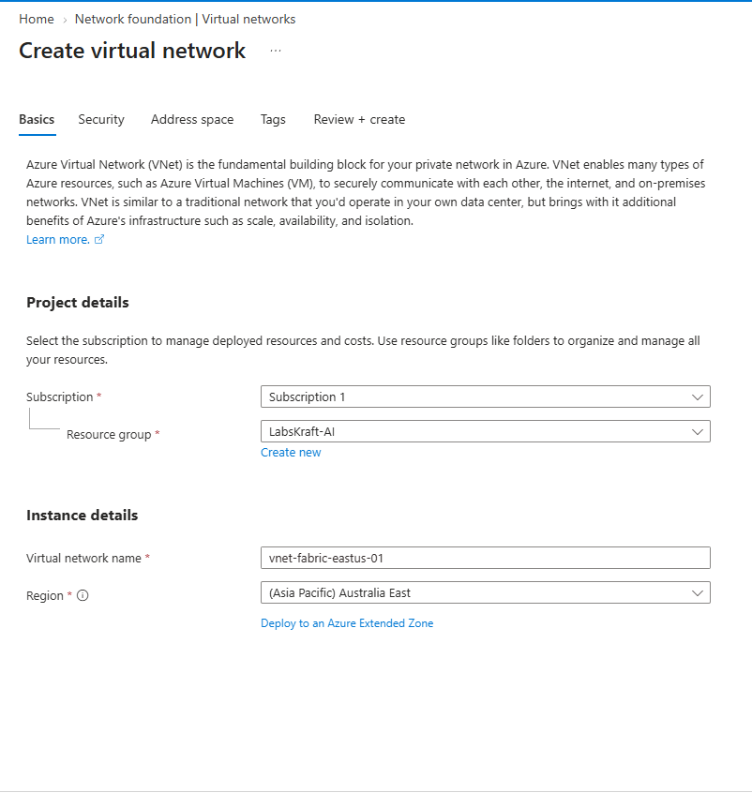
- Security Tab: Leave defaults.
- IP Addresses Tab:
  - Address space: 10.200.0.0/16
  - Add a subnet: Name it snet-private-endpoints, Subnet address range: 10.200.1.0/24.
- Click Review + create -> Create.
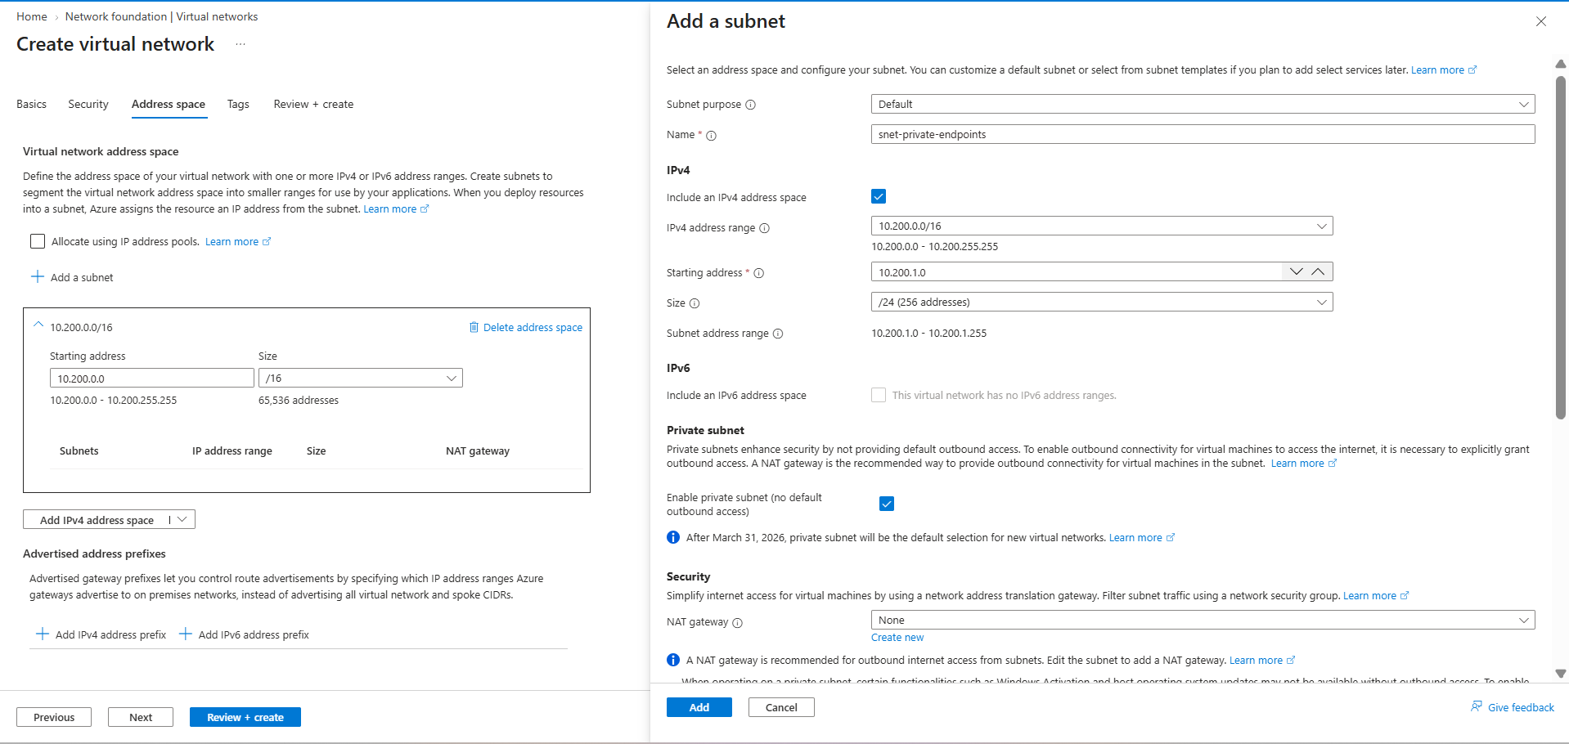

Expected Output: Provisioning finishes with status provisioningState: Succeeded.

Step 2: Create Private DNS Zones
- Search for Private DNS zones in the Azure Portal search bar, click + Create.
- Resource Group: LabsKraft-AI.
- Name: privatelink.dfs.core.windows.net. Click Review + create -> Create.
- Repeat to create a second Private DNS Zone named: privatelink.pbidedicated.telemetry.microsoft.com.
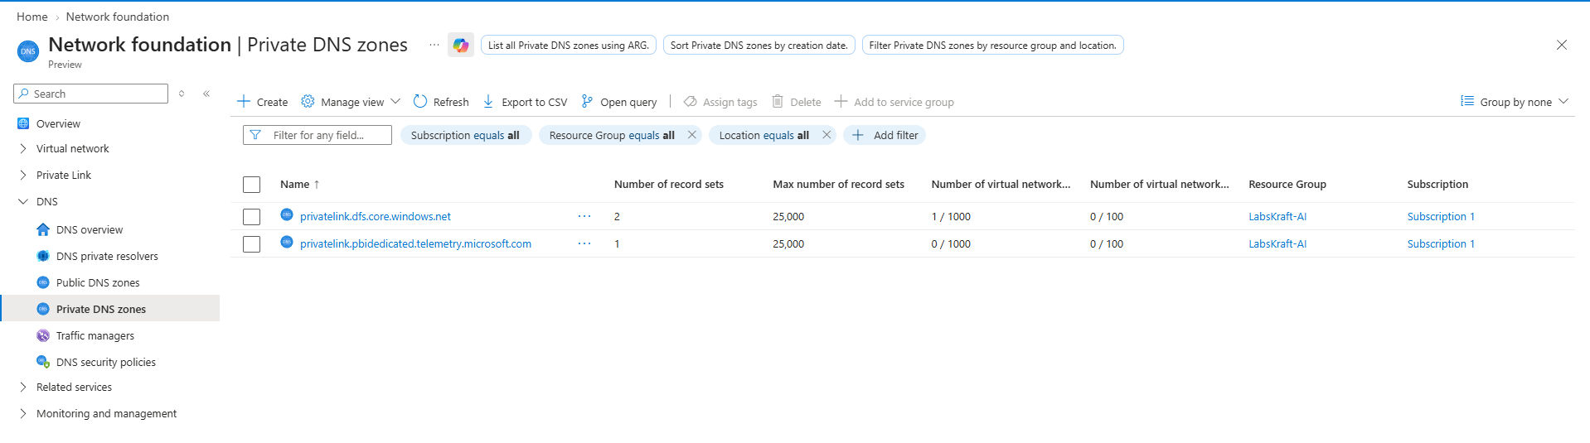
- Link to VNet: Open privatelink.dfs.core.windows.net, click Virtual network links on the left -> + Add. Link it to vnet-fabric-eastus-01 (disable registration). Do the same for the telemetry zone.
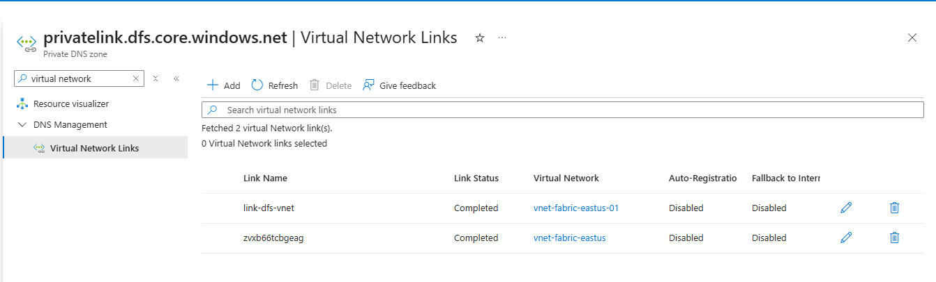
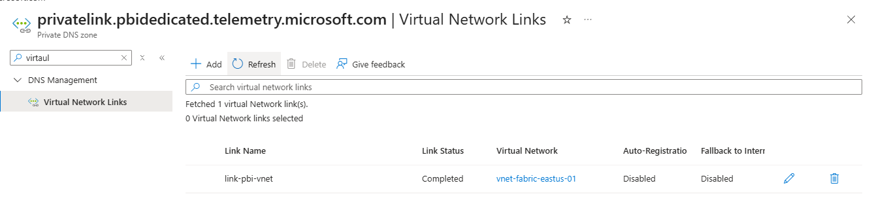

Step 3: Provision Log Analytics Workspace
- Search for Log Analytics workspaces in the Azure portal -> + Create.
- Resource Group: LabsKraft-AI.
- Name: law-fabric-security-audit.
- Region: Australia East. Click Review + create -> Create.
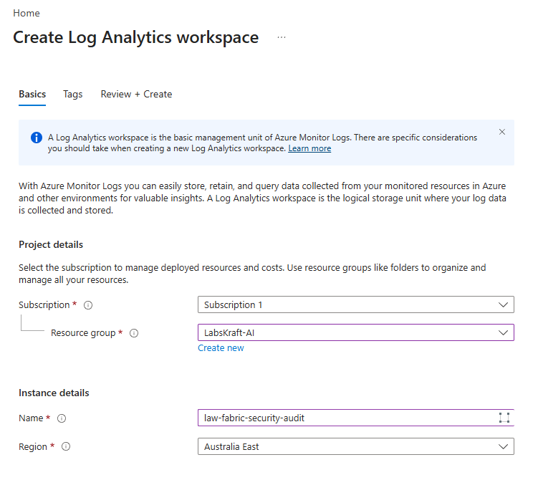

Phase 1: Fabric Workspace Network Isolation & Zero-Trust Governance

Step 4: Create Secured Workspace in Fabric Portal
- Navigate to Fabric: Open the Microsoft Fabric Portal ([https://app.fabric.microsoft.com](https://app.fabric.microsoft.com)).
- On the left navigation bar, select Workspaces and open your pre-provisioned workspace named labskraft-data.
- Ensure the workspace is assigned to your dedicated Fabric capacity under the workspace advanced settings.
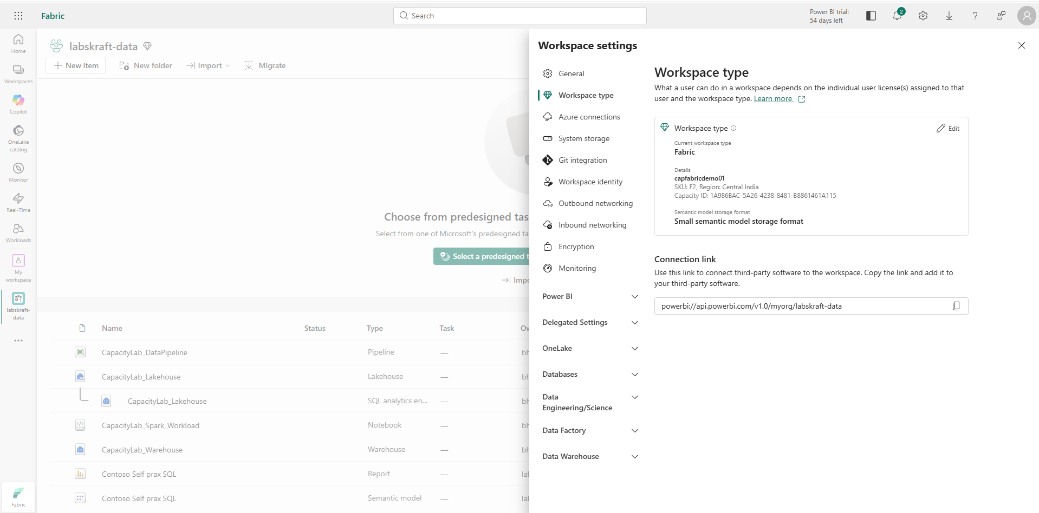
Expected Output: Workspace labskraft-data is verified and configured under dedicated Fabric capacity.

Step 5: Enable Workspace Managed VNet and Inbound Data Exfiltration Controls
- Inside labskraft-data, click Workspace settings in the top action bar.
- Select Network security from the side menu.
- Toggle Workspace Managed VNet to Enabled.
- Set Public Network Access to Disabled (Private Endpoints Only) to enforce zero-trust access principles. Click Save.
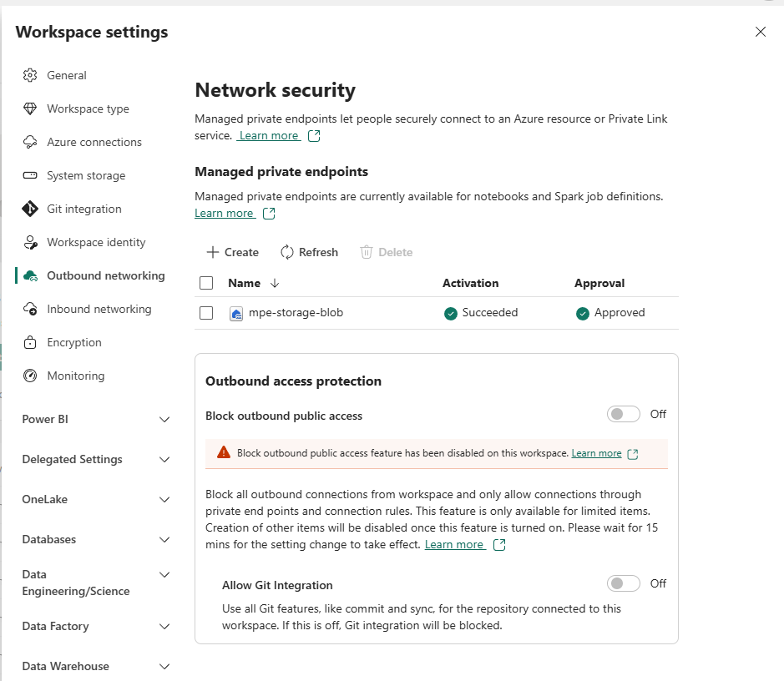
Expected Output: Managed VNet displays status Provisioned with public access disabled.

Step 6: Configure Tenant-Wide Private Link Controls in Fabric Admin Portal
- Click the Gear icon in the upper-right corner and select Admin portal.
- Click Tenant settings and scroll to Advanced networking.
- Locate Tenant-level Private Link, toggle it to Enabled, select your target security group or organization scope, and click Apply.
- Leave Block Public Internet Access as Disabled to maintain administrative portal session connectivity from public IPs while satisfying tenant private link prerequisites.
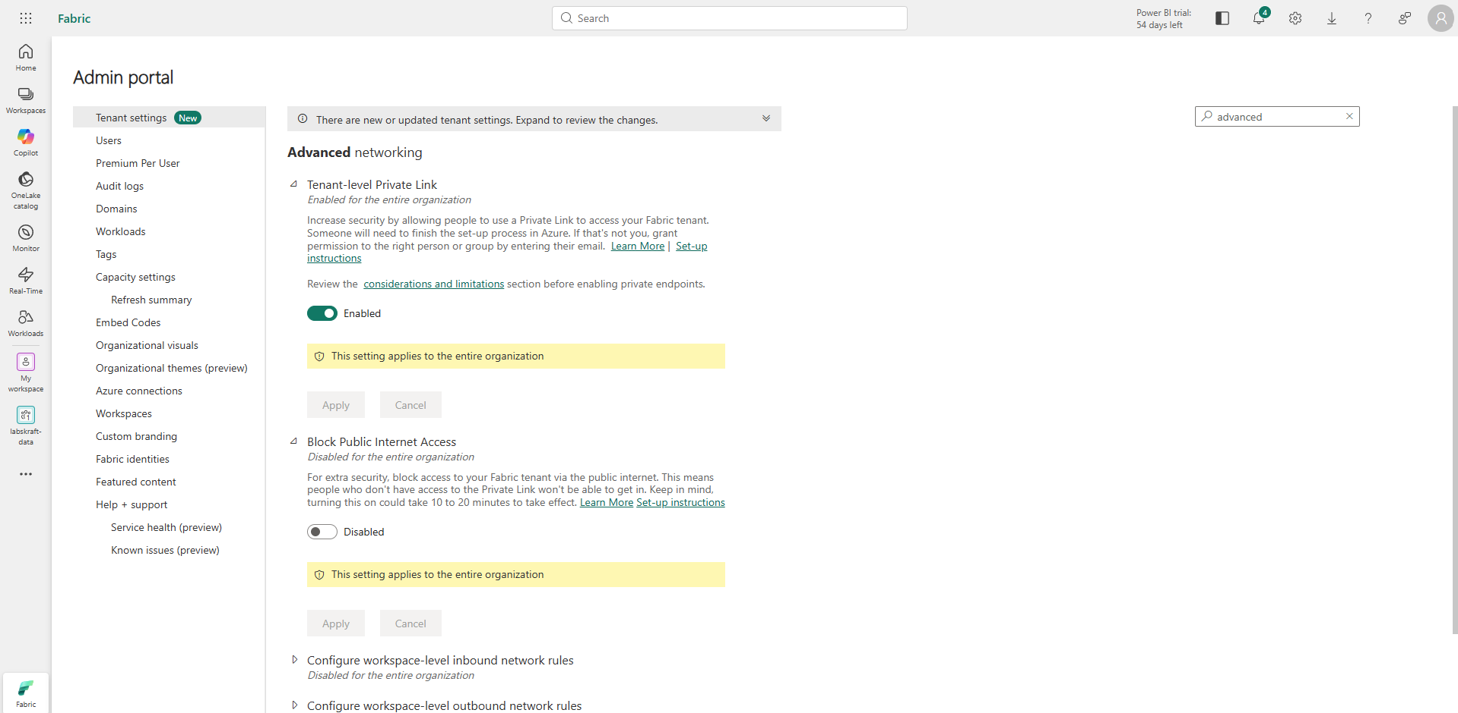
Note: That tenant-wide network policies (such as Azure Private Link and blocking public internet access) require global or Fabric Administrator role permissions to configure.
Expected Output: Tenant-level Private Link is successfully enabled, establishing private networking boundaries while preserving public session accessibility to prevent admin lockout .

Step 7: Provision OneLake Managed Private Endpoint to Azure Data Lake Storage Gen2
- Navigate back to labskraft-data, select Workspace settings -> Network security.
- Click + New private endpoint.
- Enter the Resource ID of your external ADLS Gen2 storage account and set Target sub-resource to dfs.
- Click Create.
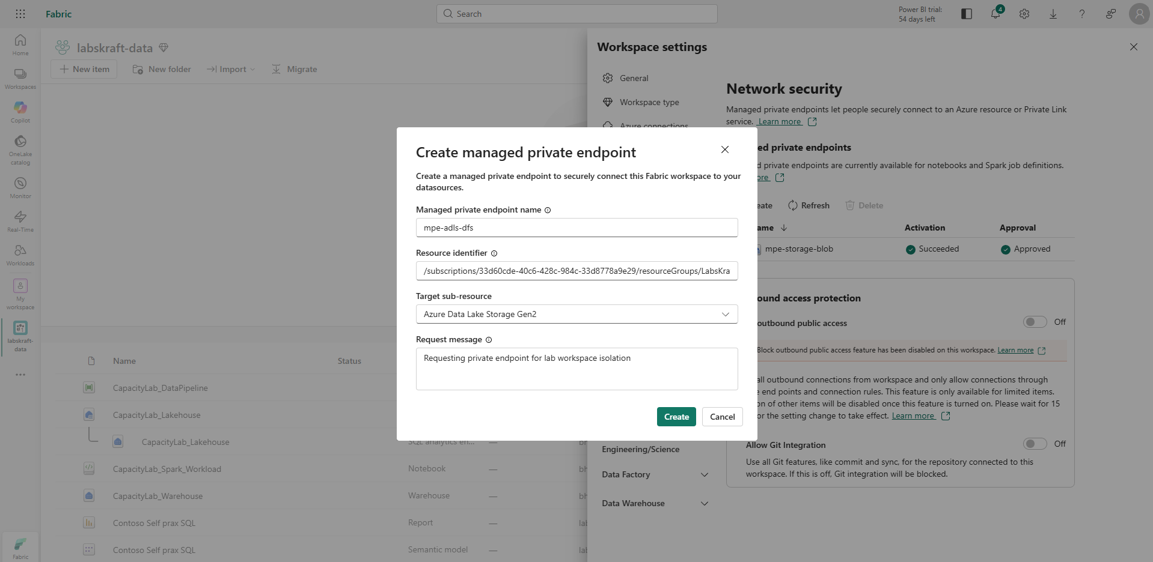
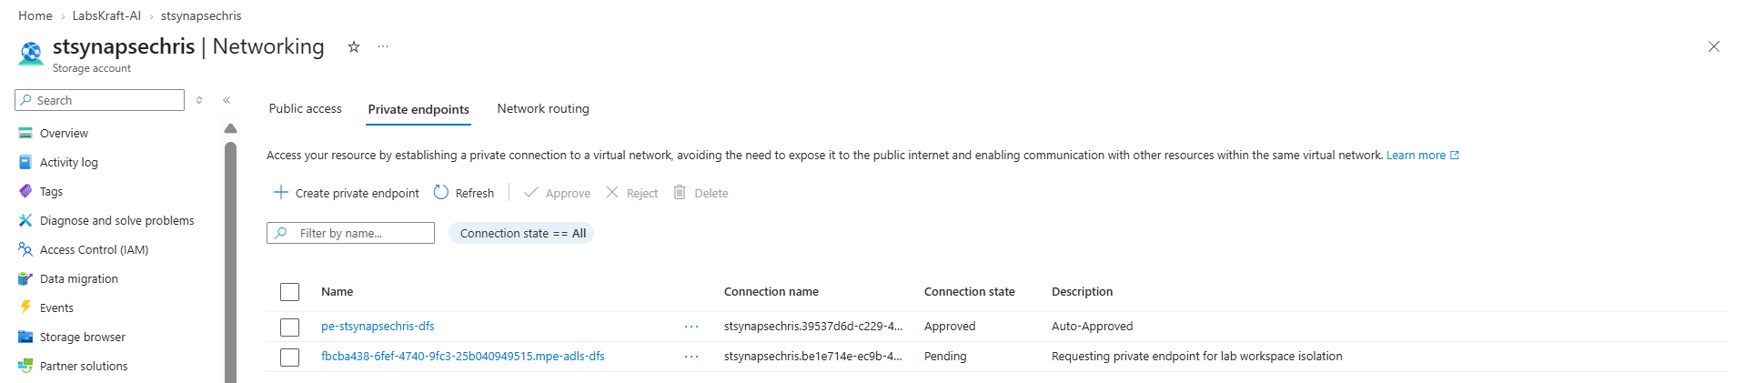
Expected Output: Managed Private Endpoint status displays Pending Approval.

Step 8: Approve Pending Managed Private Endpoint in Azure Portal
- Open the Azure Portal and navigate to your ADLS Gen2 Storage Account.
- Select Networking under Settings on the left panel, then click the Private endpoint connections tab.
- Select the pending connection request from your Fabric workspace and click Approve.
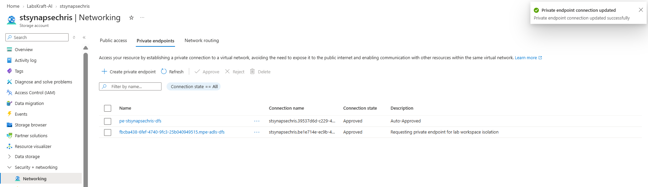
Expected Output: Connection state updates to Approved.

Phase 2: Integration Runtimes & Hybrid Gateway Architecture

Step 9: Provision a Gateway Infrastructure VM in Azure
- Open Virtual Machines: In the Azure Portal search bar, type Virtual machines and select it, then click + Create and choose Azure virtual machine.
- Basics Tab:
- Subscription: Select your active lab subscription.
- Resource Group: Choose LabsKraft-AI.
- Virtual machine name: Enter vm-fabric-gateway-host.
- Region: Select Australia East.
- Image: Choose Windows Server 2022 Datacenter - x64 Gen 2.
- Size: Standard_B2s or Standard_D2s_v3
- Administrator account: Set username to azureuser and password to LabsKraft@12345.
- Networking Tab:
- Virtual network: Select vnet-fabric-eastus-01.
- Subnet: Select snet-private-endpoints.
- Public IP: Select None (to ensure no public IP exposure, matching the zero-trust architecture).
- Click Review + create, verify the configuration, and click Create.
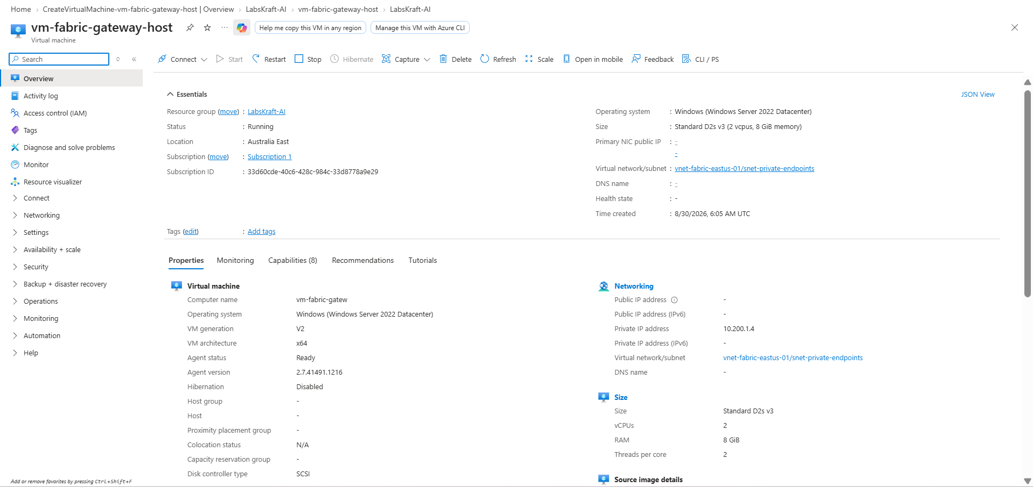
Expected Output: VM provisioned inside private subnet snet-private-endpoints without public IP exposure.

Step 10: Create and Delegate a Dedicated Subnet, then Configure the Virtual Network Data Gateway in Fabric
- Create a Dedicated Empty Subnet in Azure:
  - Open the Azure Portal, search for Virtual networks, and click on vnet-fabric-eastus-01.
  - Click Subnets on the left-hand menu, then click + Subnet at the top.
  - Enter a name for the gateway subnet (e.g., snet-vnet-gateway).
  - Specify an available address range (e.g., 10.200.2.0/24) that does not overlap with your existing private endpoint subnet. Leave other defaults as-is.
  - Click Add to create the subnet.
- Configure Subnet Delegation for Power Platform:
  - Click on your newly created subnet (snet-vnet-gateway) from the subnets list.
  - Locate the Subnet delegation section.
  - Open the dropdown menu and select Microsoft.PowerPlatform/vnetaccesslinks.
  - Click Save at the top to apply the delegation.
- Provision the Virtual Network Data Gateway in Microsoft Fabric:
  - Open the Microsoft Fabric Portal, click the Settings (Gear icon) in the top-right header, and select Manage connections and gateways.
  - Click on the Virtual network data gateways tab across the top navigation bar.
  - Click New to open the creation panel and configure the following parameters:
    - License capacity: Select your active capacity (capfabricdemo01).
    - Azure subscription: Select your active lab subscription.
    - Resource group: Choose LabsKraft-AI.
    - Virtual network: Select vnet-fabric-eastus-01.
    - Subnet: Select your newly delegated subnet (snet-vnet-gateway) from the dropdown list (it will now be fully active and selectable).
  - Enter a unique gateway name (e.g., vnet-gateway-lab02) and click Save.
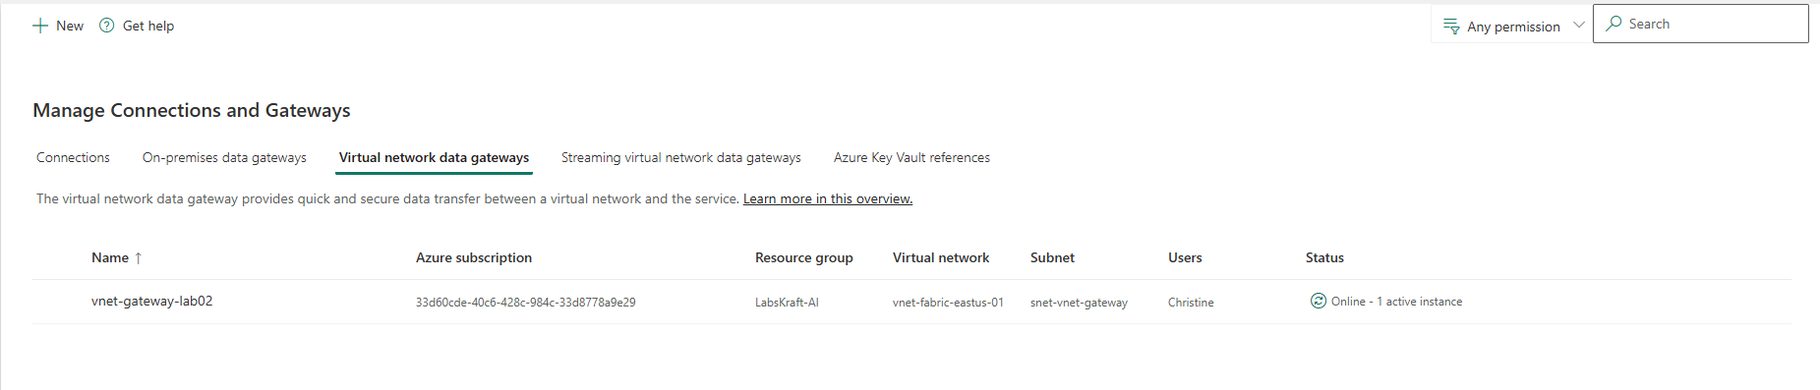
Expected Output: The virtual network data gateway status displays as active, establishing a secure hybrid networking bridge into your private VNet subnet.

Step 11: Bind Workspace Connections to VNet Data Gateway
- Navigate to Workspace: Open your Fabric workspace (labskraft-data) and open your target Dataflow Gen2 item.
- Configure Connection Settings: Inside the Power Query data source configuration, select or create your Azure Synapse Analytics connection.
- Assign VNet Gateway: Explicitly select your newly provisioned virtual network gateway ([Virtual Network] vnet-gateway-lab02) from the Data gateway drop-down menu.
- Authenticate & Select Table: Set the Privacy Level to Organizational, sign in using your organizational account credentials, click Next, and choose your target table (vw_EnterpriseSales) to preview and create the dataflow.
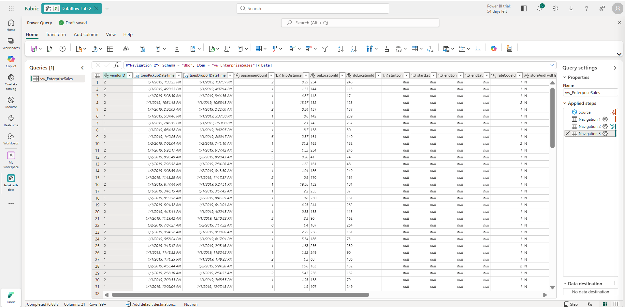
Expected Output: Data connections are successfully authenticated and configured to securely route through the managed virtual network data gateway into the private subnet.

Step 12: Validate VNet Data Gateway Status in Fabric
- Return to the Microsoft Fabric Portal under Manage connections and gateways -> Virtual network data gateways.
- Locate your provisioned VNet data gateway to verify its status.
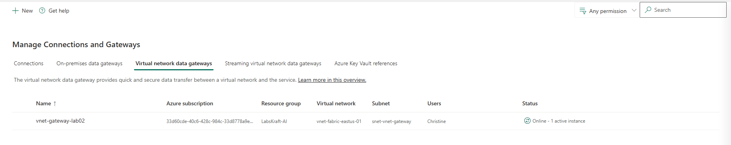
Expected Output: The status indicator confirms an active state, verifying that the secure hybrid networking bridge into the private subnet is operational.

Phase 3: Zero-Trust Security Baseline & Access Validation

Step 13: Conduct Zero-Trust Security Baseline & Access Audit Verification
- Open Cloud Shell and execute an attempted connection test to OneLake endpoints over public routes:
Bash
# Verify public connectivity is blocked (Zero-Trust Validation)
curl -v -X GET "https://onelake.dfs.fabric.microsoft.com" --max-time 5
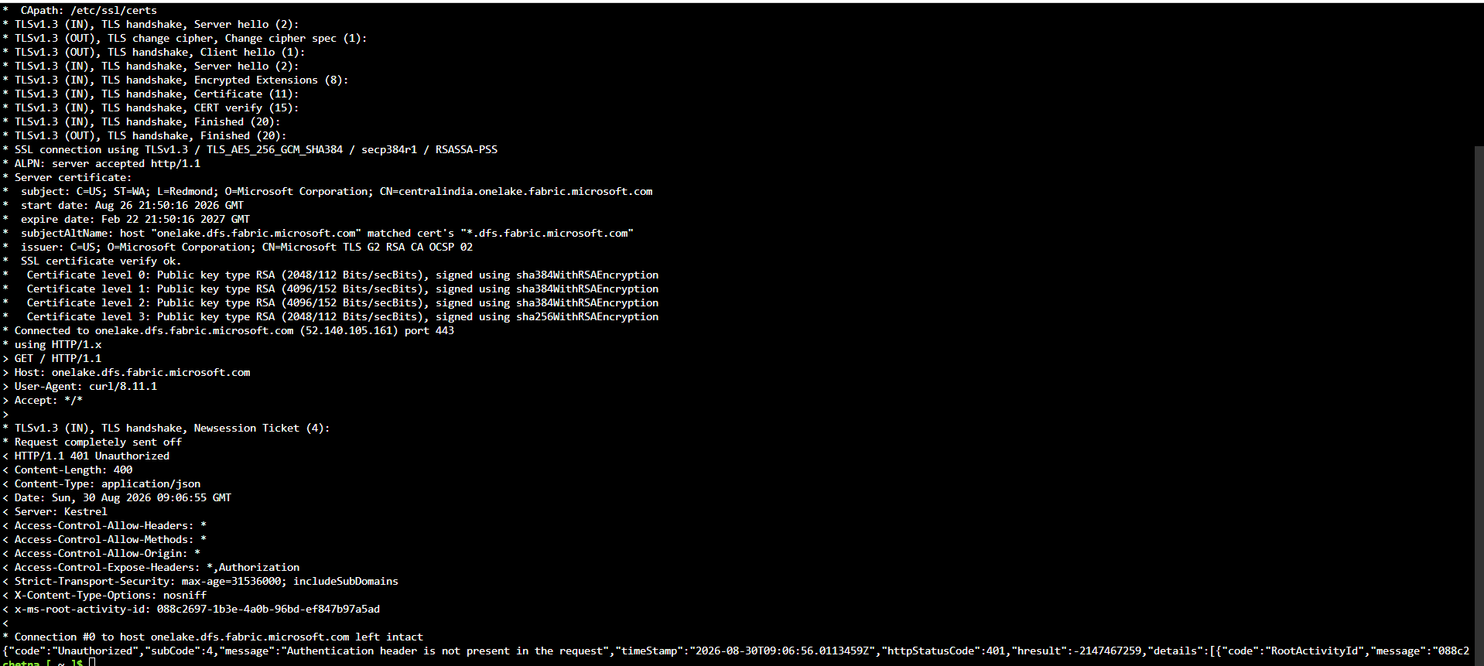

Expected Output: Connection times out or returns HTTP 401 Unauthorized, verifying successful network isolation.

Verification Checklist
Execute the following script in Azure Cloud Shell to confirm the network state of your Private Endpoints and DNS Resolution:
Bash
az network private-dns record-set a list --resource-group "rg-fabric-networking-prod" --zone-name "privatelink.dfs.core.windows.net" --query "[].{Name:name, IP:aRecords[0].ipv4Address}" -o table

Expected Result Table:
Name | IP
@ | 10.100.1.4
*.onelake | 10.100.1.5

